The making of Hell:Re/Spawn
(name in working)

It is currently 2 months into development that i decided documenting my work could be beneficial, either for getting support towards the project, as in a publisher, or having something to show of in interviews as i plan to stop living by scraps.

The past month i’ve been working on developing a mainline story, the character designs with the help of my talented sister and girlfriend, the stat/ability system, the baseline of the shop but for the past week all i’ve done is making pixel art as I’ve come to the conclusion that nobody will be able to draw the characters the way i envision them but myself, so i guess the start of this documentation will mainly be pixel art from the game.

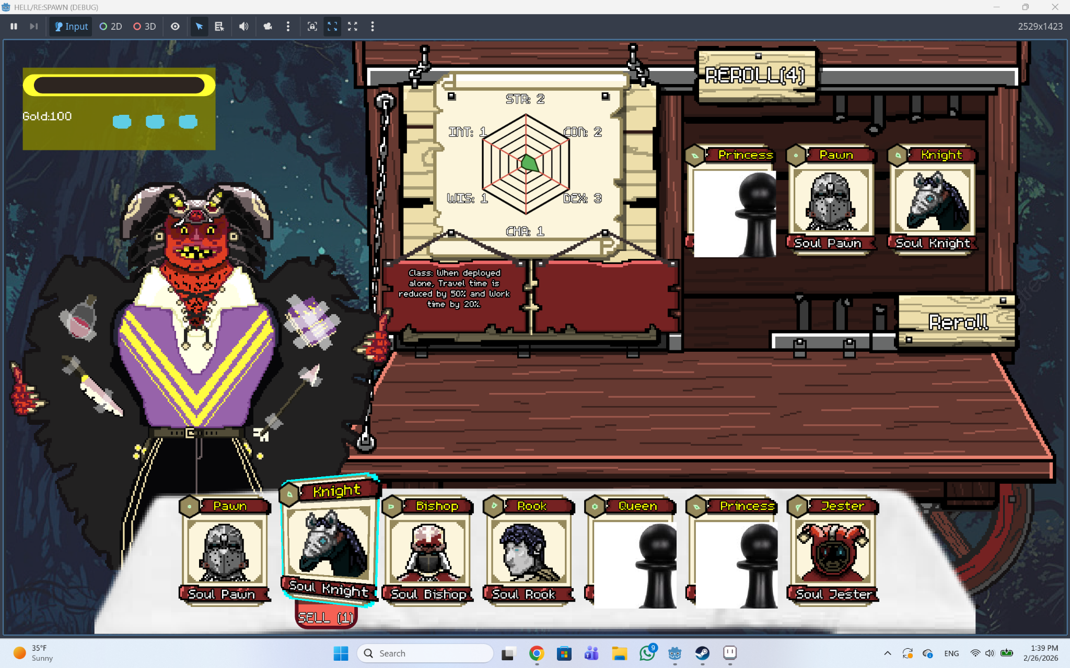

Here we can see the Shop which i m really found of, rerolling for units, and items which i ve currently not created, some cards have missing assets, the background needs to be changed as it’s a placeholder, but all in all i really love the vibe of it, i ve been stuck a lot on the card design but i think simple’s the best choice and been making the portraits fo the starting hand, the soul units which are the Soul fragments of the king’s (the player) trustful companions from his human life, after defeating a demon lord the king will recover the whole soul of one of his friend, and that card will be a strong one to be available in future runs.

Story
You were beloved king, but you could father no children, you prayed to god for a child and he delivered a daughter, but she’s been born an Angel, when Lucifer (the final Boss and the Strongest Demon Lord) saw this happening, he came to earth and destroyed your Kingdom as a rebelion to god’s intervention on earth, taking the souls of everybody you’ve known, but your soul is useless to him, as you’re to devoted to god, so he punishes you to be reborn as a hellspawn each time you die, endless torment in hell.
Here come’s the name Hellspawn respawn which i thought a clever joke with the word Pawn as it started as a chess inspired game.

Gameplay
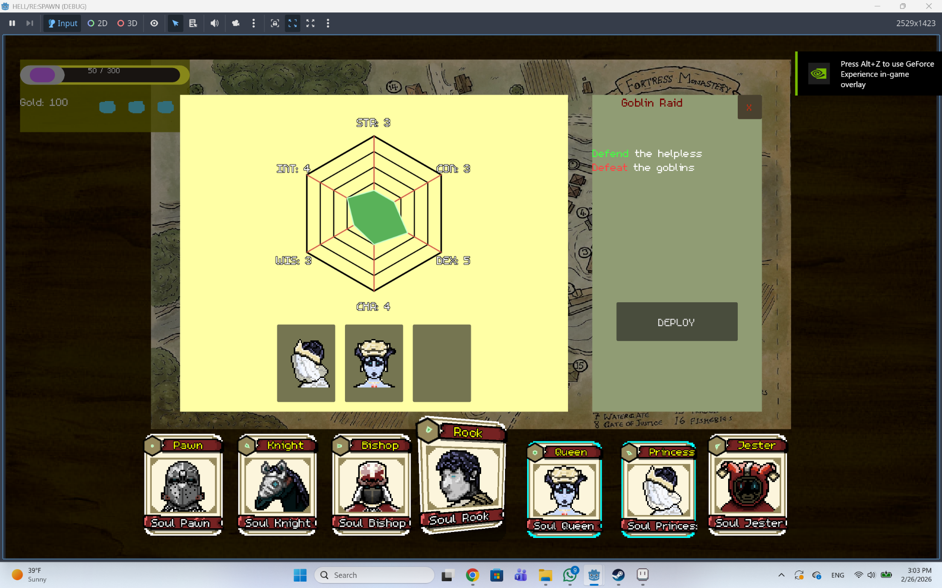

I’m making the game using godot as a game engine and aseprite for the art.
The gameplay loop is pretty similar to dispatch, sending units on missions, each with their class ability and their own ability, but as i’ve only developed the basic units, they only have their class abilities. I’ve still got to change most of the ui into pixel art but i’m taking my time learning to code a game from scratch and refining my art.

If this document finds anybody that feels an intention to contact me, feel free to use this email address g.ghinda@yahoo.com

